DRIVING LICENSE CANCELATION SYSTEM

# CS6308- JAVA PROGRAMMING

**MINI PROJECT:-**

# TEAM MEMBERS:

## VIGNESH P – 2018103080

## PRAVIN K – 2018103050

**PROBLEM STATEMENT**

The violation of road safety rules are increasing day by day. People don’t cares about the traffic laws enforced by the government. And some people use the road transport for some illegal activities. Road accidents take place due to some inept drivers. The judiciary department is already taking care of cancellation or suspension of driving license for the above mentioned cases. But it is a manual process and it consumes more time. It also takes a lot of procedural steps. Manual error is a concern. Manual errors are common in such a complex system. Another concern is the maintenance of data. It is a hierarchic process and the process are inter related to each other (completion of one process lead to the initiation of another process). The above mentioned statement refers to the attributes of complexity. This project provides solution for the problems mentioned in this paragraph.

**DRIVING LICENSE CANCELATION SYSTEM**

RTO officer plays a major role in the system. RTO officer creates new license entry, update license and cancels the license on certain condition. The license will have merit points added to them. If the license holder involves in breaking of laws or involve in any of the activities against the law then the traffic police department files a case against the license holder. The case history is added to the database. The system automatically checks the data base and based on the section of case history the system detects the merit points from the license. Then the RTO officer cancels the license (deletes the license entry).

**Java concepts used in the system**

* Jframe class acts as a super class for other classes in the license cancelation system.(inheritance).
* JDBC (java Database Connectivity) is used to connect to the MYSQL database and store data.
* Every class implements an Inbuilt interface called as ActionListener to sense the user activities in GUI.
* Java swing provides a GUI (graphical user interface) which helps the users to easily access the system.

Outcomes of the System

* RTO officer can handle the license records with ease.
* Automates the process of cancelling license when the license holder involve in any activities that are against law.
* The system follows a merit based process.
* Helps the judiciary department to directly enforce the punishment without following the manual process.

# Front end: Java - Swing, AWT.

# Back end: MySql, JDBC.

# Classes used in project:

1. Preindex.java
2. connection.java
3. AdminLogin.java
4. RTOlogin.java
5. JOlogin.java
6. LicenseHolderLogin.java
7. Admin.java
8. RTO.java
9. JO.java
10. LicenseHolder.java
11. New_RTO.java
12. New_JO.java
13. Del_RTO.java
14. Del_JO.java
15. New_License.java
16. Update_License.java
17. New_Merits.java
18. Update_Merits.java
19. Cancel_license.java
20. AddCase.java
21. EditCase.java
22. View_License.java

# Screenshots of the input and output:

Page for selecting the login for different users

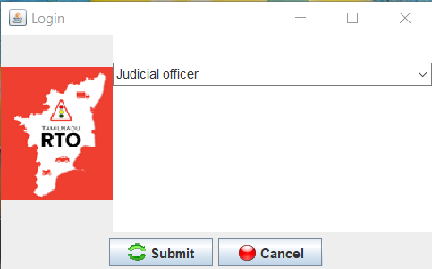

Judicial officer login

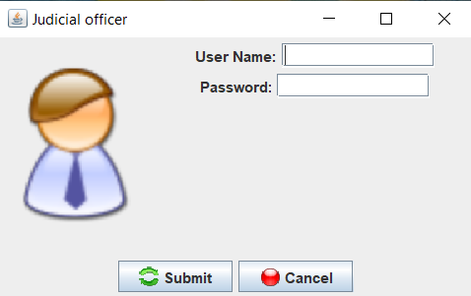

Message displaying invalid login for entering wrong user ID or password

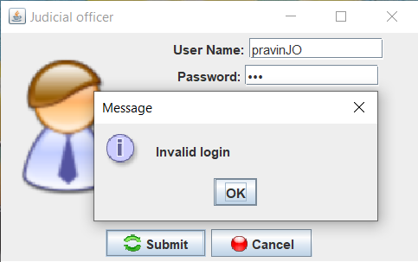

Default page for judicial officer. It has funcionalities to add or edit case on license holder and logout.

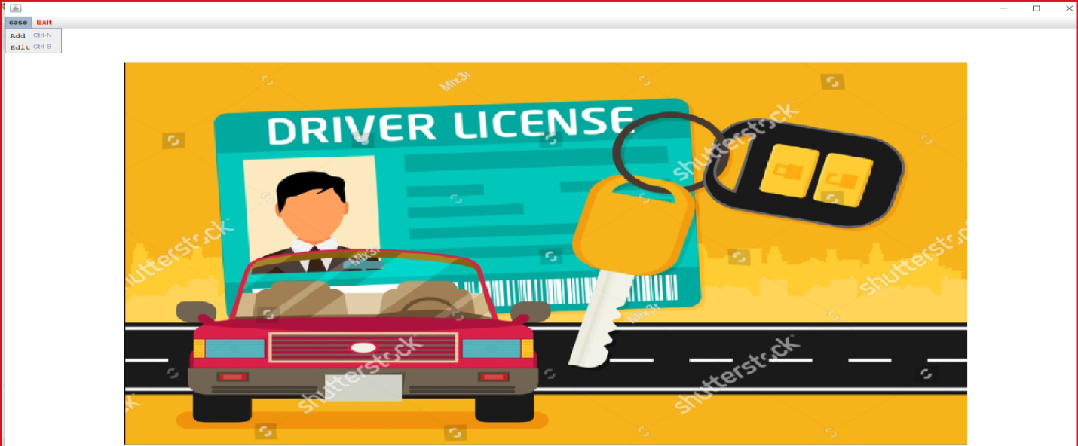

Filled case by entering the required details

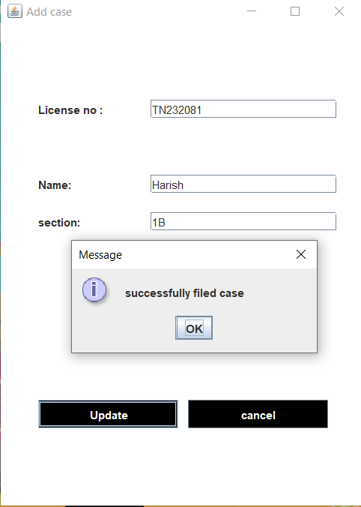

The case history will be edited when we enter required details.

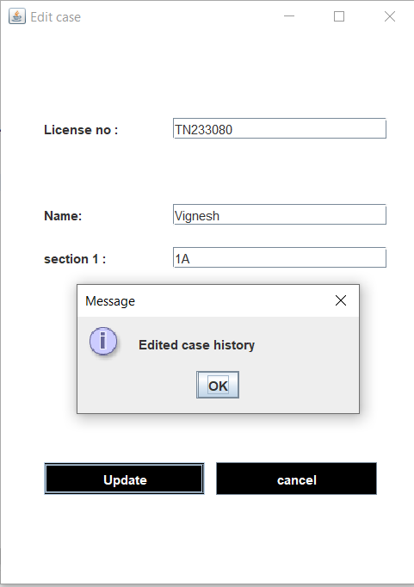

Default page for license holder. It allows the license holder to view their information and merit points.

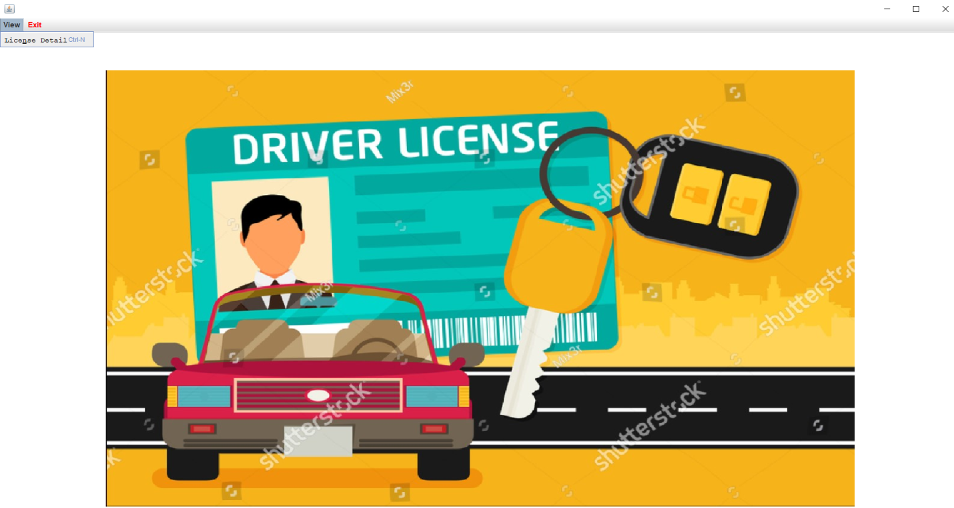

The license holder can view their details by entering the right credentials.

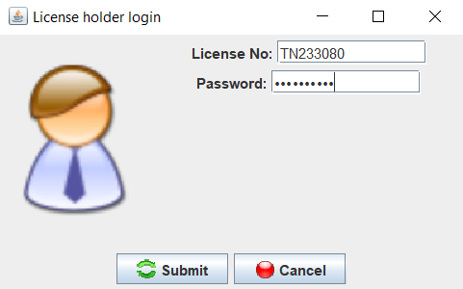

The license holder’s detail is displayed.

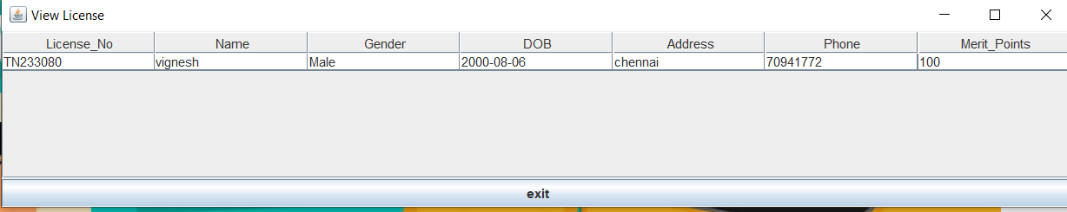

Admin login page

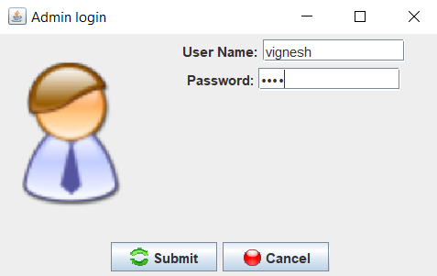

Default page for admin. The functionalities provided for the admin is to add or delete RTO officer and Judicial officer.

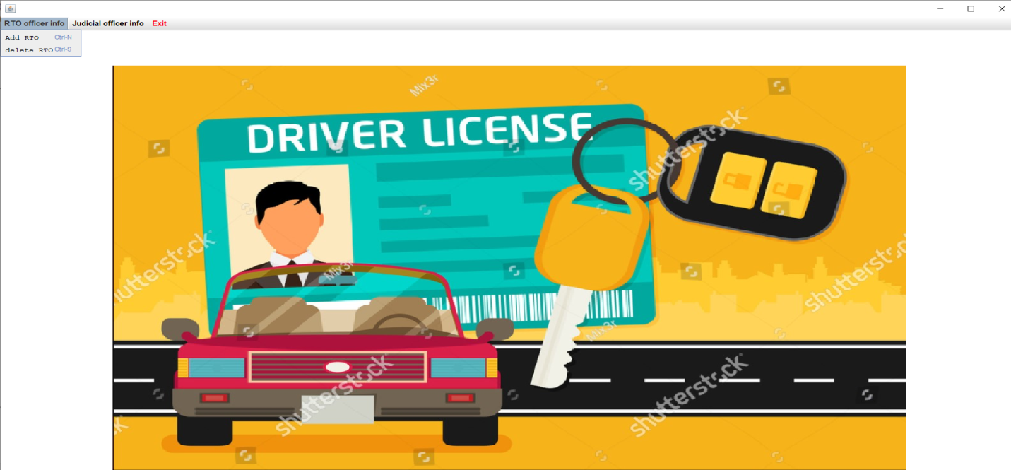

A new RTO officer ID is created.

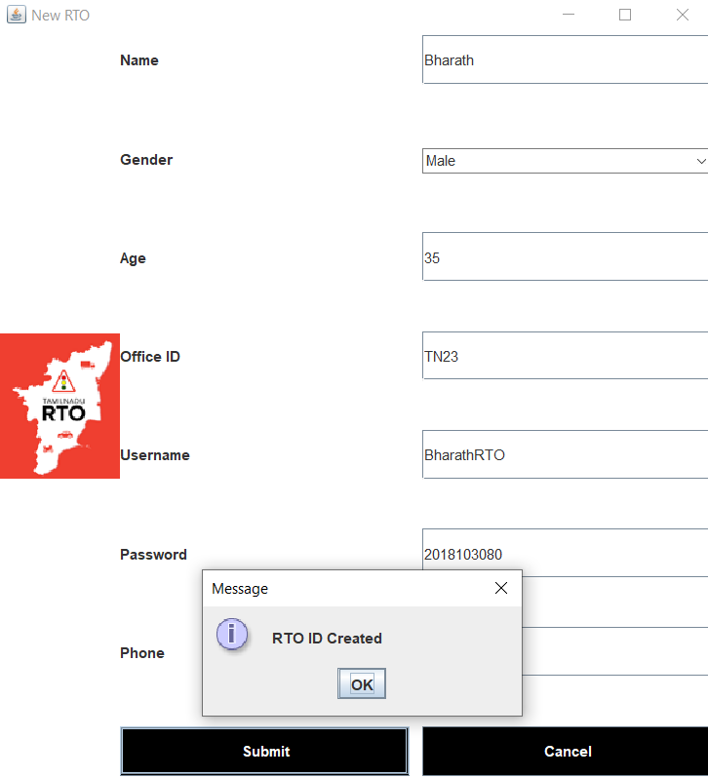

Deleted the RTO officer entry by entering the ID.

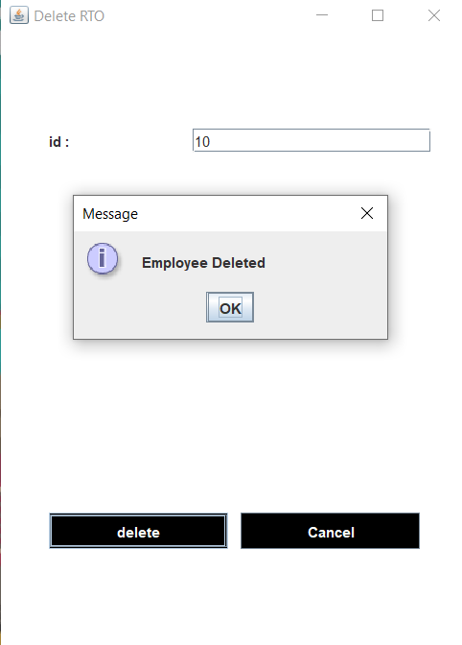

By entering the required details an entry for judicial officer can be created.

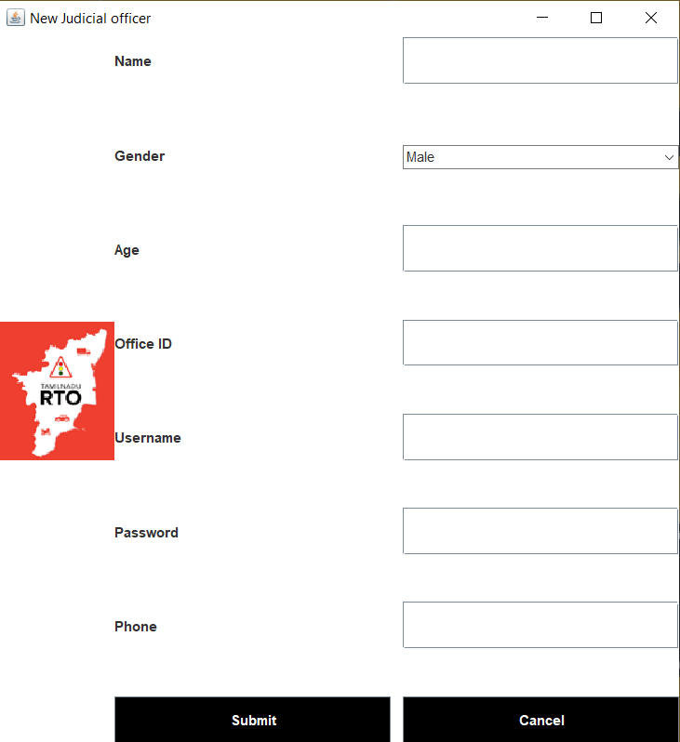

Login page for the RTO officer.

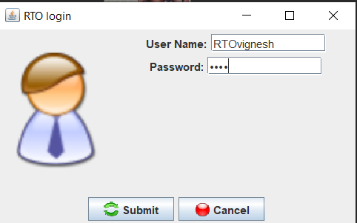

Home page for RTO officer. RTO officer can add, update or cancel license. The RTO officer can also alter the merit values and can view the license entries which have merit points less than the threshold points.

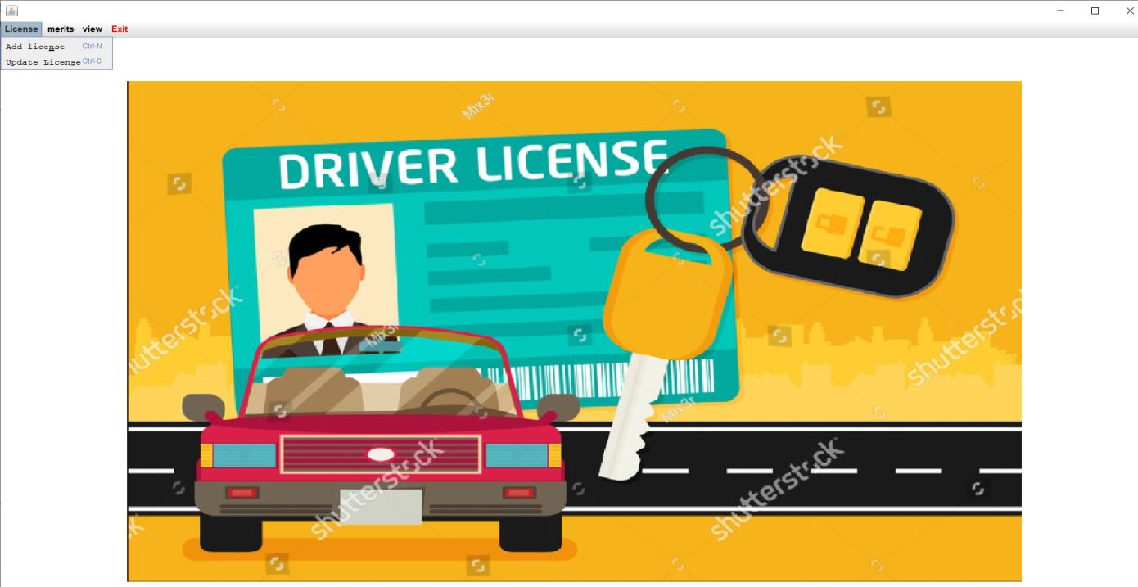

License is created by entering the required details.

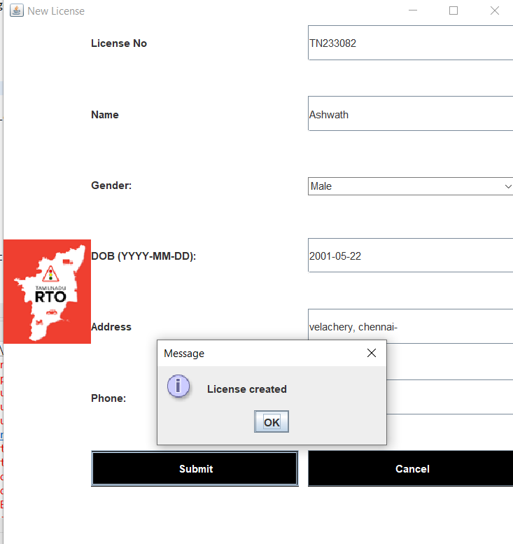

The license detail is updated.

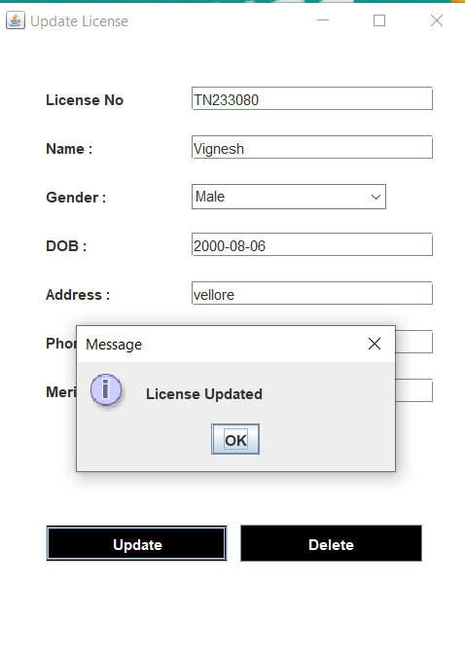

License is cancelled by entering the requierd details.

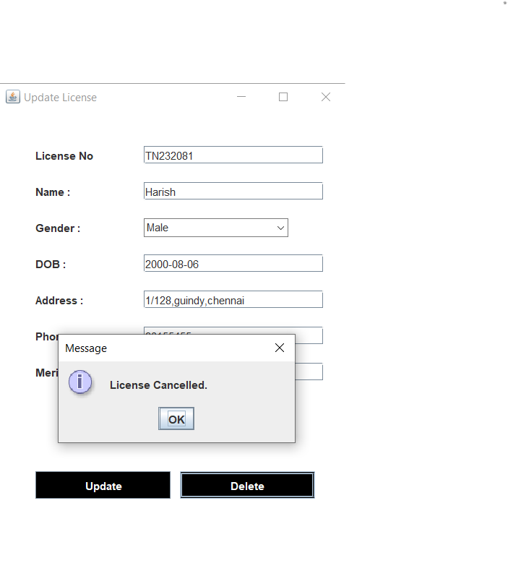

New merit is created for the section.

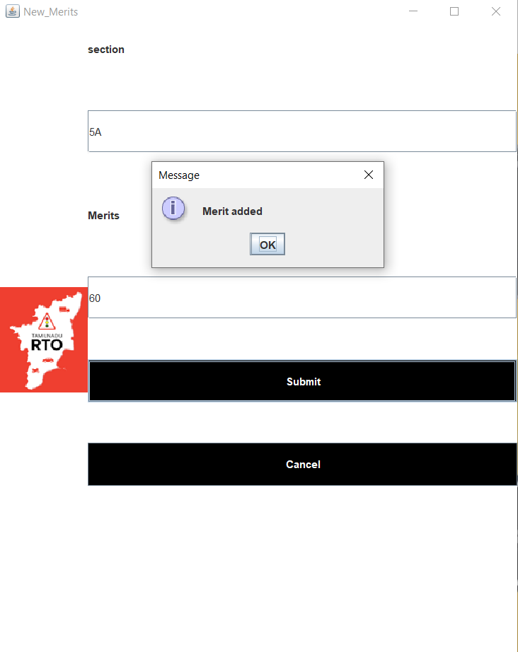

Already existing merit is altered.

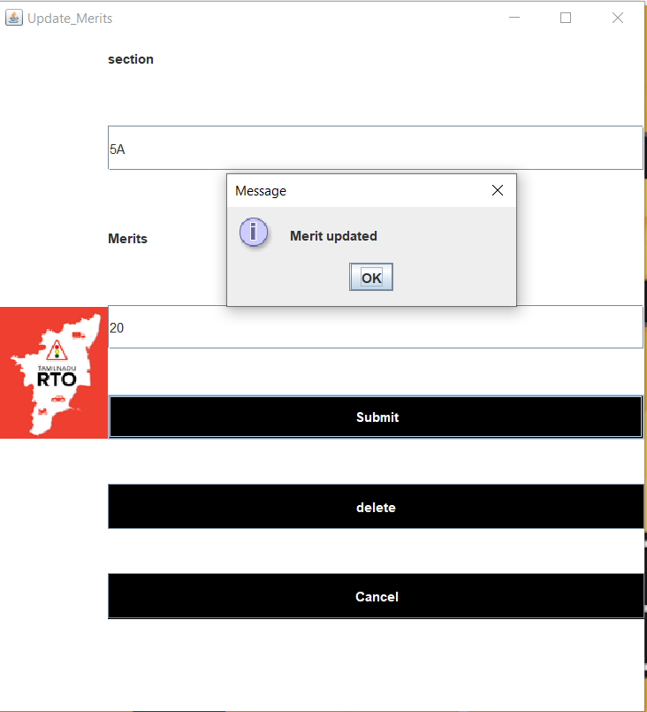

Existing section and its merit is deleted.

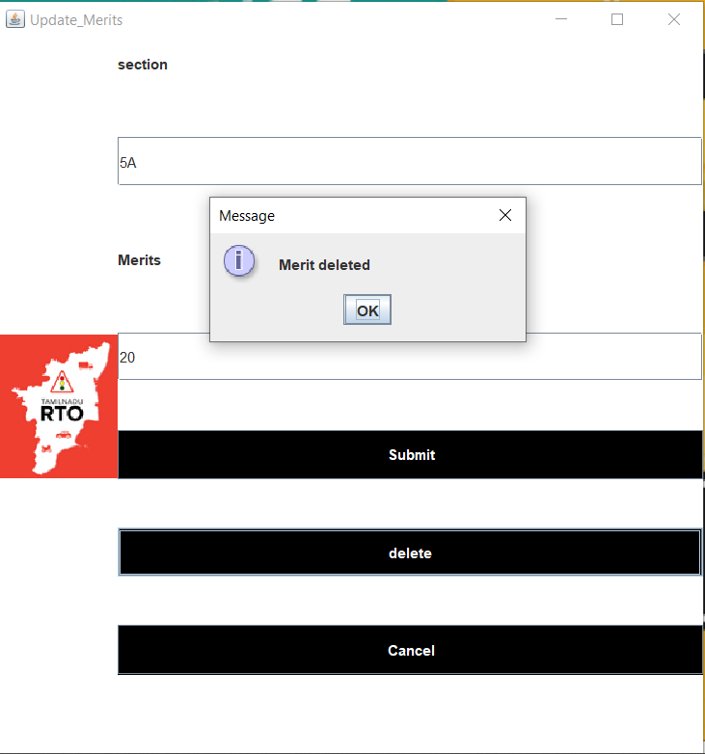

RTO views the license holders with merit points less than 50. And by pressing the cancel license option he can cancel the license.

